Bonduel Elementary

Fourth Grade Handbook



Mrs. Steinbach Mrs. Suehring  
715-758-4850 Ext. 135 715-758-4850 Ext. 137  
[steintra@bonduel.k12.wi.us](mailto:steintra@bonduel.k12.wi.us) [suehrnic@bonduel.k12.wi.us](mailto:suehrnic@bonduel.k12.wi.us)

**Table of Contents**

Introduction_________________________3

Responsibilities______________________4

Curriculum

Math___________________________5

English Language Art _____________5

Science _______________________6

Social Studies ___________________6

Handwriting ____________________6

Technology_____________________6

Assignments

Corrections_____________________7

Absentee Work _________________7

Student of the Week_________________8

Citizen of the Month_________________8

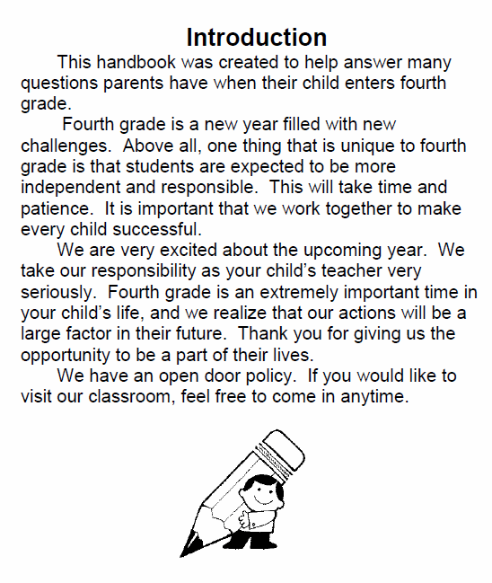

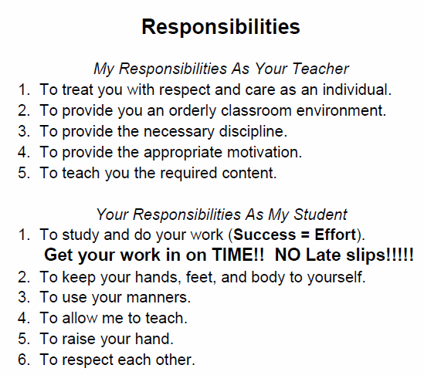

**Curriculum**

**Math**

We will be using the Math Expressions series. Each day we will begin with our Math Talk before the lesson. Students will use the Homework and Remembering sheets to practice the skills learned in each lesson. Some skills we will be working on include multiplication, division, fractions, and geometry.

The students will be responsible for knowing their multiplication and division facts.

**English Language Arts**

We will be using the Journeys series. Each week we will focus on a new Essential Question to help build our skills in writing, comprehension, fluency, and language. We will be using this series for our grammar and spelling as well.

We will also be supplementing our ELA curriculum with trade books, Time for Kids, and Accelerated Reader (AR).

**Science**

Using the Science A Closer Look series, we will be learning many new things about plants, animals, machines, and even the human body! There will be numerous hands-on activities throughout the year!

**Social Studies**

We will be using the Harcourt Social Studies States and Regions book to learn about our country! In addition, we will be learning about our great state using the Wisconsin, Our State, Our Story book.

**Handwriting**

It is expected that fourth grade students have already mastered cursive writing.

**Technology**

Students will be using the laptops for various things throughout the year including research, AR tests, typing, and educational games. We will be using the program typing.com to practice our typing skills. Students will need headphones for many of the applications we use!

**Assignments**

**Corrections**

Your child has the wonderful opportunity to make corrections on daily assignments that are below 78%. If a daily assignment is passed back with a failing score, we will encourage them to make corrections and remind them that they are **due the following day.** It will be a choice that the student makes. Corrected assignments will only be raised if all the incorrect answers are correct. Assignments can only be passed in for corrections one time. If corrections are made, they can receive a passing score of 78%.

**It is the student’s responsibility to make these corrections.**

**Absentee Work**

If a student is absent for more than 2 days, it is important that they complete work before a known absence or while absent to make sure they are prepared when they return. Assignments will be posted on the classroom TEAMS page. While absent, if a student needs help, they should contact their teacher via email or TEAMS!



**Student of the Week**

Each week a student who has had an outstanding week will be chosen to be Student of the Week. They will get to decorate their poster and bring in pictures/objects that symbolize them. On Friday, they will be able to give a short presentation.

**Citizen of the Month**

Each month a student who has shown many positive life skills. They will be given a certificate and a Project TEAM point!